Screenshots from TemperatureController (STM32F103 project)

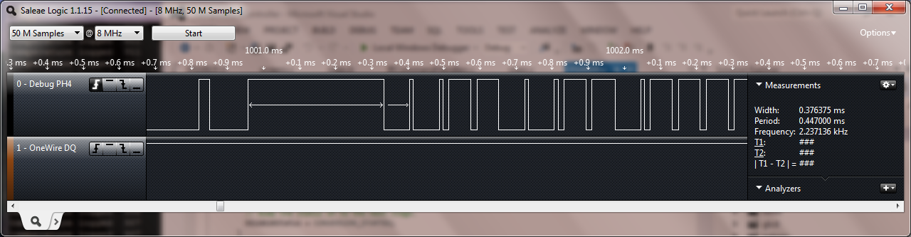

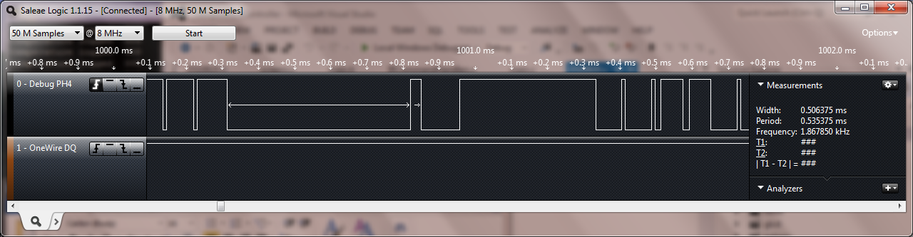

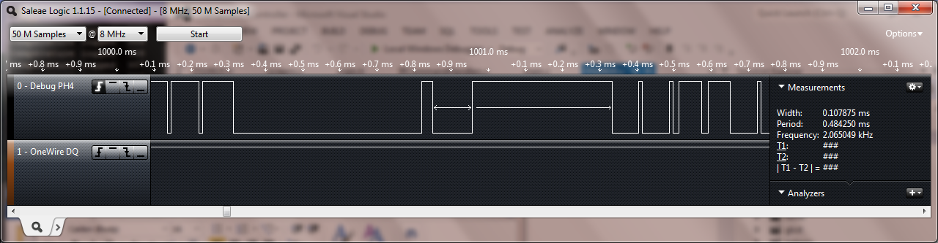

Reset low for 500us, pulse high for 30us or so, then low for 100us.

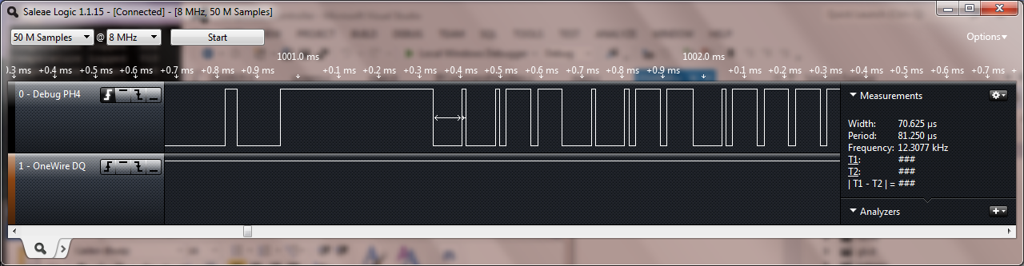

Data 0 = low for 70us, high for 10us.

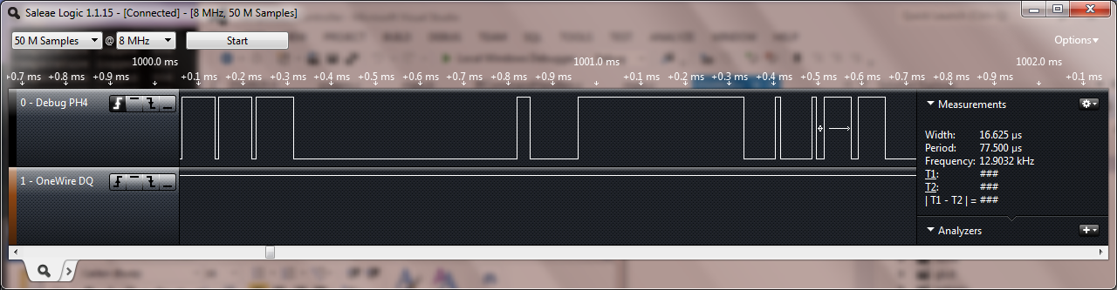

Data 1 = high for 60us, low for 16us.

Screenshots from DS18B20 (STM32F407 project)

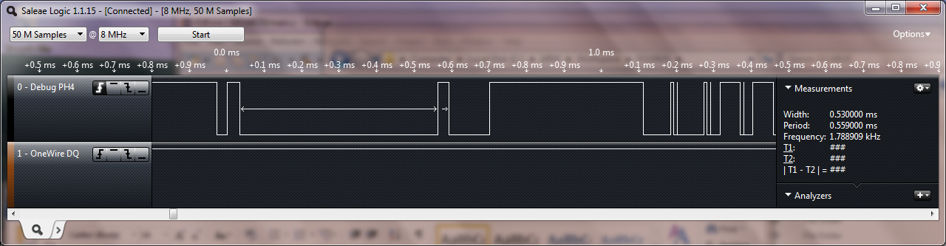

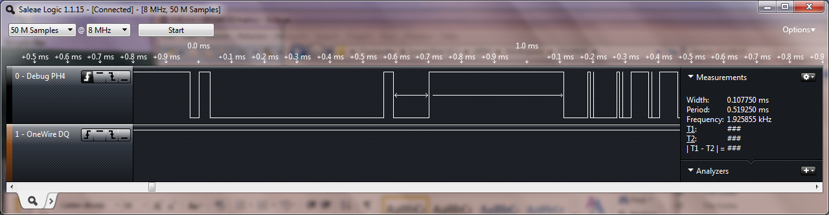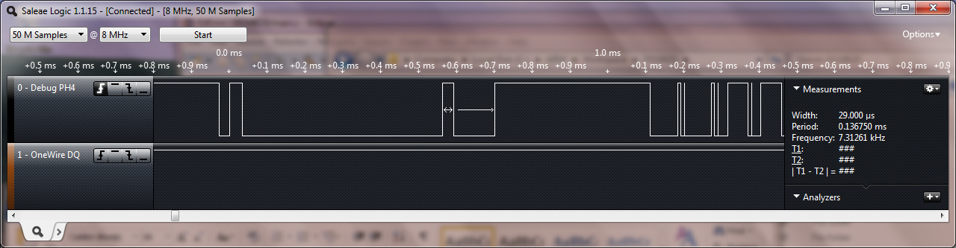

Reset low for 530us, pulse high for 29us, then low for 107us.

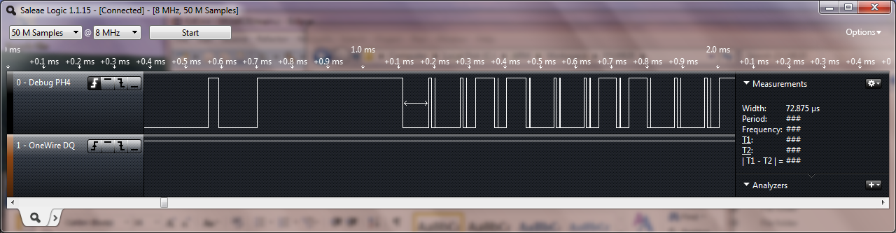

Data 0 = low for 72us, high for 7us.

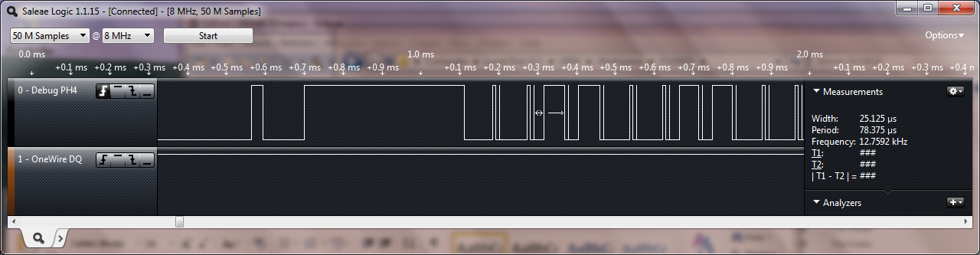

Data 1 = high for 53us, low for 25us.

Odd pulse high-low are 0.6us wide. These don’t appear on the STM32F103 project.